BAD BOYS


BAD BOYS?
Left to right: Kurt, Winston, Kevin, Walid, Cass

This extract is from Chapter 22 where Kurt gets lost in Thailand but learns things he’d never have learned back home in north London.

…..I checked these new surroundings: lake, sky, the forested hills that stretched darkly into the setting sun, and the man who’d just appeared sitting cross-legged on the grass. This was no longer the flat view from the bus window but genuine 3D reality, and I was standing there amongst it with my earphones dangling, as if I’d just been beamed down from somewhere.
I was used to measuring distances in yards, not horizons. I was used to seeing colours in shades of brown and grey, not in full Technicolor orange, pink, white, and pale blue with shadows of green, black, and grey. The sun was a bright red sphere behind the palms, and there was movement on the water - ripples between big circular leaves of crimson water lilies.
When the guy moved and nodded his head in my direction, I admit I took a step backwards. Strangers don’t nod like that in north London. Neither do people deliberately block your way because they’d be trampled to death. They pass by looking at phones and living in a virtual world because the real world is too horrible to see.
I checked him out from a safe distance.
I’d only been there a day or so. Since leaving Phuket, I’d seen locals but not a foreign-looking guy with long matted hair hanging from his head. My mother used to like blokes with that sort of hairstyle where it’s hard to see a face, but she used to prefer curly black dreadlocks, not straight, greying hair.
He wore a khaki vest, so you could see his hairy armpits. His orange trousers stopped just below his knees. His arms were sun-burned and covered in tattoos. His legs were crossed, but his bare feet rested one on top of the other at his crotch, with a pair of sandals lying behind him on the grass. To me, he was more like a sun-tanned hippy sort than Rasta, although both might have had pockets filled with little screwed-up packets and a cheap lighter.
Then he spoke. It sounded to me like “please” and “sit,” so I moved forward and crouched down low enough to peer at a face that looked as if it had been crafted from brown shoe leather. Perhaps my crouching suggested I was using the spot for another purpose because his next words shocked me. “I said sit, not shit.”
The words, more in the lavatorial style of Coolie, came from inside the hair and were made with an American accent, but I found my voice. “Sorry, mate,” I said. “Do you come here often?”
It was the sort of chat-up line I often use for fresh acquaintances, although I admit it lacks refinement. On this occasion, too, it lacked the accompanying wolfish grin I once used on someone called Linda at the Cougar Club on Smith Street who then led me to the far corner of the Smith Street car park.
“Occasionally,” he replied, and I, assuming that was the end of the matter, eased a displaced ankle back into my Nikes, patted my back pocket for the satisfying bulge that was my wallet, and tried to squeeze past. But I had only taken three strides when I heard his American voice from behind.
“Your phone, sir.”
Sir? I patted my other pocket and found it empty. My ear plugs were still hanging, but there was nothing attached so I turned to find the man holding my Samsung in his hand, turning it over, and examining it with interest. “It must have fallen out,” I said. “Can’t live without a phone, can we?”
He pushed his greasy locks back and looked up at me with half-closed eyes, as if he’d not slept too well.
“It’s dead,” I added. “It needs recharging.”
“A solution not available to a dead man,” he replied.
I like fresh phrases and was sure there was a joke there somewhere, but a quality reply evaded me. “Sorry?” I said, pretending I hadn’t heard.
“Would you like to be recharged after you’ve died?”
“I don’t know,” I said.
He looked up at me. “Are you a happy man?”
“What?” I asked somewhat rudely.
“Are you on vacation?”
“Yeh,” I said bravely. “We all need to get away now and again. The nine to five, the tax, the government—know what I mean?”
Again, I hoped that was the end of the matter but no. “Are you in a hurry?”
I didn’t answer because I’d once received the same question from a bald middle-aged man in a raincoat outside a public toilet when I was twelve. As I’ve mentioned before, Park Road was, and still is, a very mixed community.
“Please sit.” Perhaps it was the way he said it, but it sounded more like a command and I found himself in a no man’s land of uncertainty. Much as I wanted to, I couldn’t just snatch my phone back and walk away. After all, I’d inherited a few manners from somewhere, though it is hard to know how. So, I sat on the grass with my knees around my ears, wondering why I hadn’t just said, “No, thanks, mate. Cheers, but I’ll be on my way.”
I got my phone back. It was returned by a bony hand, with fingernails that looked as if they’d been digging for mushrooms or something. I swiped the blank screen just in case there was a flicker of life still left in it, but there was none.
“It’s dead,” the man said, replacing his hands on the lap of his loose-fitting orange trousers. “Why not let it rest in peace?”
“But it’s got all my stuff on,” I said.
“Stuff?”
“Contacts and stuff.”
“Does it know how vital it is to your existence?”
“It’s only a phone, mate.”
“But it seems to me you regard it as a vital necessity, a lifeline that you cannot allow to become detached from. Does it talk to you? Advise you? Teach you?”
“It could if I downloaded the right software,” I said.
“So, your phone, this machine, this piece of technology is part of you?”
“Sort of. This is not a cheap phone, you know.”
He was staring at me with sleepy black eyes, and I wondered if I could now go on my way, but he suddenly raised his right hand and pointed towards the trees on the edge of the lake. “Before it died, did your phone see the kingfisher on the eucalyptus?”
I looked where he was pointing, but perhaps the kingfisher had flown away.
“Did your phone see anything today? Did it marvel at the sky, the clouds, the lake, the grass, the trees? Did it watch the butterflies? Did it see the white egret that took flight when you approached? Did it share with you what it saw? Did your phone tell you what it heard today? The cry of the kingfisher? The gentle sound of fish jumping in the water? The breeze in the bamboo? Did your phone feel anything today? Sadness, happiness, contentment, enthusiasm, enlightenment? Did it ask you questions? Test you? Advise you? Did it perhaps enquire about its origin—where it came from, who made it, and what might happen to it when you no longer need it? What does your phone think? What does it like? What does it dislike?”
Each of his hundred questions was asked at the speed of light, and I had forgotten the first long before the last, but they’d made me think. “It’s only a phone, mate,” I replied because that was the sort of answer I’d normally give to multiple questions.
“Are you saying that your phone has limitations, that there are things it can’t do that you can if you so wished, that there are things it can’t do that an animal or plant can?”
I was getting confused. Despite his American accent, this guy was asking the sort of questions that Willie used to ask in the middle of a lesson where he was supposed to be teaching us about isosceles triangles. Willie’s words from five years ago rang in my head. All I’d done was murmur, “Fuck,” too loudly, and he came over and walked around me while tapping his own head with a ruler.
“Can you do calculus in your head, Kurt? How about working out the relationship between a set of inputs and outputs, Kurt? If so, I suggest you apply for a job with Mr. Gates right now. Alternatively, I hear the council are looking for painters and decorators, but even so, you might need to work out how many litres of paint you need to cover twenty-five square metres of brick wall.”
I often think about Willie. This Yank was similar.
“Did you, with your greater powers of intelligence, marvel at the dragonflies over the lake? Did you notice the sky, the clouds? Did you ask why the sun is red at sunset? Did you spend any time today considering your own origin, how you grew from an egg to an adult, or what will happen to your mind and body when your own battery goes?”
I always sniff when faced with difficult questions, especially those of a personal nature, so I sniffed. “I was distracted,” I said.
“Distracted by an inanimate object.”
“What’s that?”
“Your fucking phone, dumbass.”
Something had happened to the intellectual finesse, but I was too slow to make the point. “Oh, I see what you mean. Yes, I was distracted. The battery was going.”
“So, it died like an animal, a bird, an insect, or a plant. It died like you, and I will one day?”
“Yes,” I said, “but once I plug it in, it’ll come alive again.”
I felt ashamed of my flippancy because he’d already got me thinking.
“What’s your name?” he asked.
“Kurt. What’s yours?”
“James,” he said. “You got a surname, Kurt?”
“Learner,” I replied whilst thinking he was lying. He didn’t look like a James. He looked more like a Ziggy or a Zappa or even Spiderman II.
“And where are you from, Kurt?”
“North London, mate. You?”
“Virginia. Enjoying your time here?”
“So far so good.”
“How do you find the local people, the culture?”
James’s dark eyes fixed themselves directly onto mine, but I’m not comfortable with those who try to catch me out with big words like culture. I needed time to think, so I didn’t answer because I was also wondering if James might soon decide to go home wherever that was.
I was grateful when he moved. I watched him pull a hand through his hair and, in one simple fluid moment, unwind a pair of unexpectedly long legs and stand. He was slim, agile, and even taller than me. Christ. Six foot three. Four?
“Would you say you’re lost, Kurt?”
If this was another trick question, then my priority now was to stand to at least ensure some equality in the tallness stakes. But I toppled clumsily and then had to pull the damp cotton of my pants from the cleft of my backside. Then, to my horror, I watched my precious phone roll towards the lake. James was the quickest. He bent, retrieved it, and handed it back. “Do you know where you are or which way to go, Kurt? Would you like help to get back on course?”
“No, thanks.”
“You are heading the wrong way, Kurt. You need to stop and decide where you’re going.”
It sounded to me like spiritual guidance. The sort that is, I admit, in very short supply. But I sniffed again. “No, thanks, mate. I’ll see you around.”
And with that, I headed off into the growing darkness. Mistake!
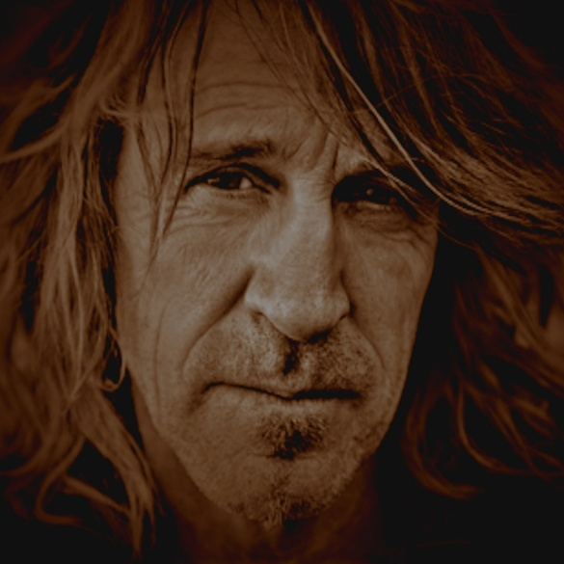
This is Jimmy, who is in this story until the very end.

