EXTRACT FROM THE MALTHUS PANDEMIC
From the Prologue.
Doctor Mustafa’s clinical trial.

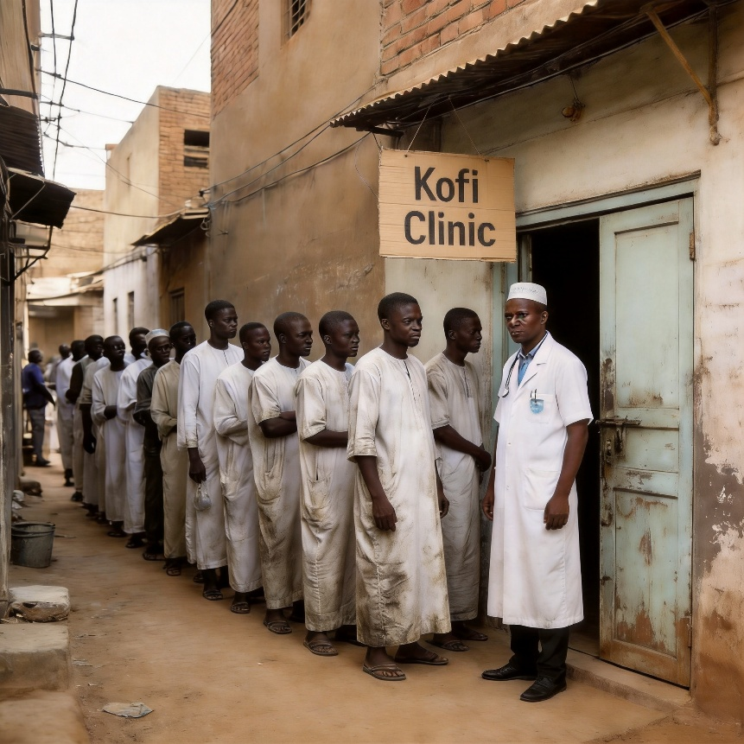

No one asked questions when the Kofi Clinic opened on that hot, dusty, and chaotic side street in the centre of Kano, Nigeria’s second city. In Kano, things just happened. People came and then they went.
Perhaps the old lady who sat mending torn clothes or the man next door who mended bicycles saw something. Perhaps, too, the old man who sat every day on an old tyre that lay amongst the accumulated urban debris and watched and listened to the crowds of jostling people, trucks, buses, taxis and carts going to and from the marketplace also noticed. But no one cared.
In a crowded city of four million people, where three million lived in poverty, why should they have noticed the stranger, a big man in a long white bubu and wearing a traditional handwoven cap? Here was a man like everyone else who came and went in the heat and dust. Perhaps only the sewing lady, the bicycle man, and the old man who sat on the tyre saw him arrive one morning and take delivery of a second-hand desk, some wooden chairs, a metal filing cabinet, and a cardboard sign printed with a red cross and the words “Kofi Clinic, Dr A. Mustafa.” Perhaps, too, they were the only ones who watched him fixed that sign above the door with a hammer and two nails.
If anyone had heard him speak, they would have heard Arabic but not Hausa, and anyway, he never stayed long enough to strike up a conversation because he’d quickly head back to his room at the Grand Central Hotel. It was there that Dr Mustafa met the white man who joined him for a quick visit to the Kofi Clinic before departing on a flight for Nairobi.
Perhaps the lady with the needle and thread overheard the short exchange as they smiled and shook hands outside the clinic. “So, David, what is your opinion?”
“Perfect!” The white man nodded. “My only concern is a power failure. Keep a close eye. The samples must be refrigerated at all times. One week should be enough, then close it.”
No one turned up at Dr Mustafa’s clinic when one evening, shortly after the white man’s visit, a light was turned on and the door was opened for the first time. No one turned up on the second night either, but on the third night, six men were waiting outside when Dr Mustafa arrived and unlocked the door. On the fourth and fifth evenings, rumour had spread that the Kofi Clinic was not a place to go if you were sick or if you felt ill but a place that offered cash for testing new medicines.
“Na sana’anta twenty thousand naira,” said one enthusiastic volunteer who emerged, waving his money to a man still waiting in the queue outside. “Easy money, man,” he added before heading off to buy a live chicken to take home to his wife and six children. And so, the news spread along the lengthening line of poor family men in their sandals and white jalabiya. “Biya mai kyau kudi” (Good money).
The Kofi Clinic, with its business finished, closed shortly after that, and Dr Mustafa was not seen again. A nail then fell from the shabby, hand-written cardboard sign above the door so that it hung at an angle.

