EXTRACT FROM LEARNING FROM VOLVOX
On money, compassion and human welfare.
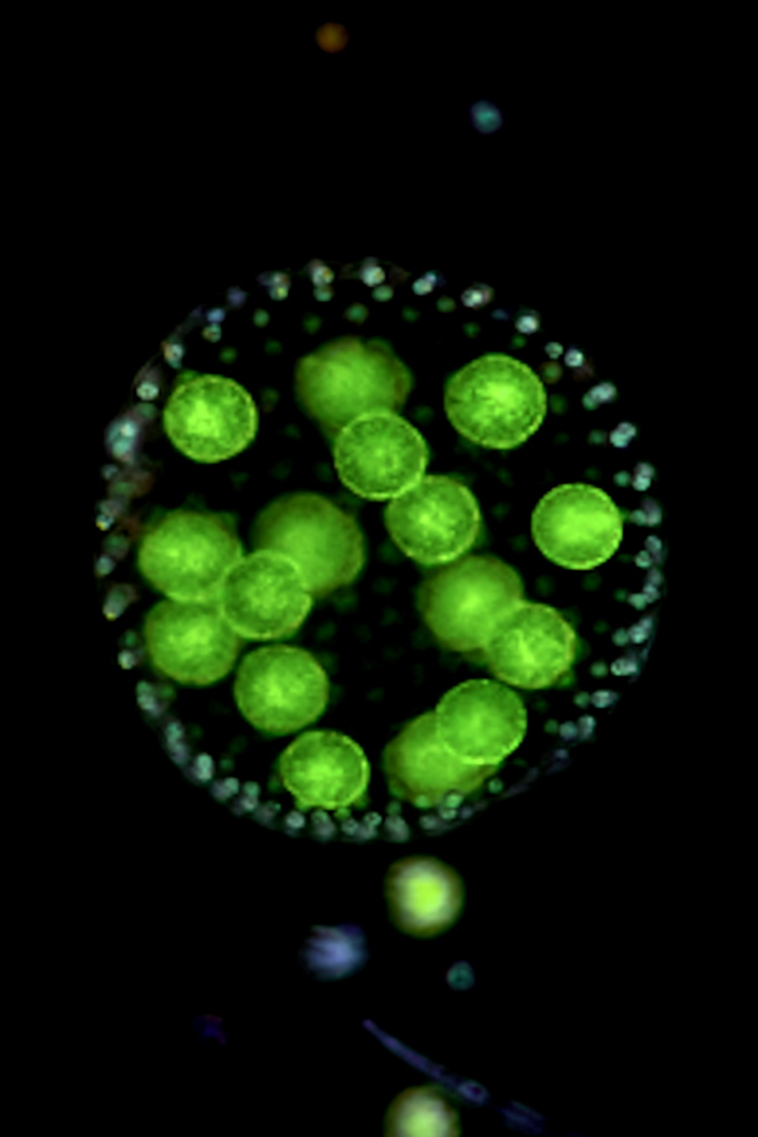

One of the earliest characteristics of human socio-cultural evolution was the invention of money. Money speaks. Money buys influence. Money supports political agendas. Money can falsify and distort scientific facts and promote them into fixed beliefs amongst millions, especially the young. Money buys scientists to support political and commercial agendas. Money changes society.
Back in post-war 1948 it was deemed a good idea by some to provide money and technology to ensure that the weak, the sick, the vulnerable and those unable to live without support would survive longer. Hence the WHO.
Rooted in human characteristics like compassion, altruism, generosity and welfare for other humans it was perfectly understandable that, for a while after 1948, the word ‘humanitarian’ rose in popularity.
Since around the year 2000, however, its popularity has declined.

Usage over time for the word ‘humanitarian’.
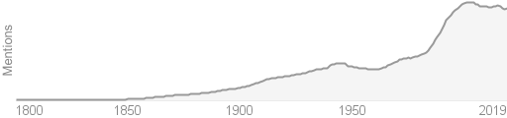

The explanation for the current decline liea in some other human characteristics – doubt, suspicion and disagreement. On ‘humanitarian aid’ these characteristics are on full display. We have:
- Suspicions about corruption.
- Doubts about whether the aid actually reaches those in need.
- Suspicions that aid only leads to a culture of dependency.
- Doubts that humanitarian aid can ever be a long-term solution.
Doubts and suspicions are perfectly understandable because since the WHO was established and the human population rose to 8 billion, the list of social, cultural and economic problems increased in direct proportion.
Again, what happened to ‘care? And where was the foresight? Where were the extrapolations to the thousands of graphs, tables and pie charts the WHO issued in the 70 years since 1948? Where, in fact, were the long-term business plans submitted with the multi-billion-dollar funding bids to the governments being asked to pay for it? Did anyone raise doubts? If so, were they ignored because they ran counter to the soft, kind, social, cultural, touchy-feely, humanitarian agenda and so might, for example, put re-election and careers in jeopardy? Did no-one ask pertinent questions before writing cheques? What happened to human intellect, foresight, imagination and critical thinking?
Humans are well known for having bright ideas that don’t work. They then might ignore the mistake using the well-known head in the sand approach or by blaming another human. Hypocrisy should be added to our list of unique, human characteristics
Nature, of course, also makes mistakes.
The difference is that nature, with its reliance on natural selection and survival of the fittest, recognises its mistakes immediately and deals with them quickly. Evolution is littered with examples of extinction caused by mistakes.

