EXRACTS FROM HUNTED
(THE BOOK IS WRITTEN AS NOTES TO THE MAIN CHARACTER’S RECENTLY DECEASED MOTHER)

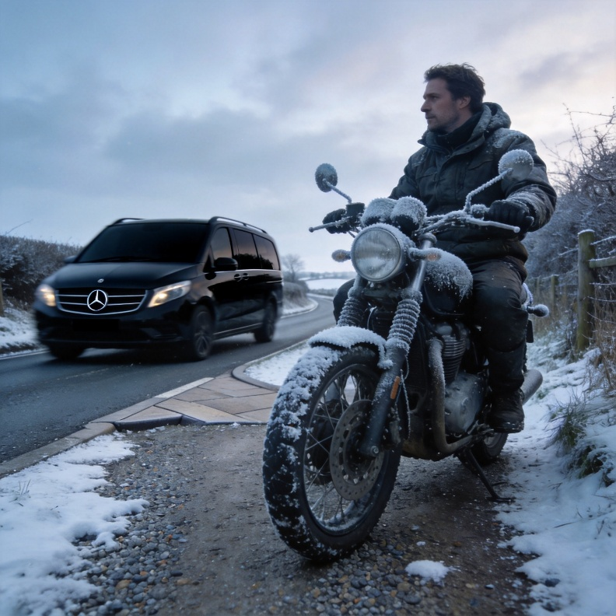

NOTE 29 THE WEATHER INTERVENES
"Blow, blow, thou winter wind, Thou art not so unkind.” (William Shakespeare, As You Like It)
…..It was cold. The weather forecast warned of snow spreading from the east so I bought another sweater and scarf and headed north west into the Cotswolds. The sky was clear blue and the sun bright but low. It was good winter walking weather but I was on a motorcycle with my face frozen into a frown and my hands difficult to prize from the handlebars. I stopped in an old market town called Moreton-in-the-Marsh which was as far as anything could be from Shanghai’s concrete and glass skyscrapers.
I had lunch in a café in an eighteenth-century house where I thawed out and was paying my bill when my phone buzzed three times. I went outside to wait. Stash, I thought, but it wasn’t.
“Josh?” said the English accent that I faintly recognised. “It’s Steve Paterson.”
Paterson: Stash’s friend who he’d met in Australia and I’d met on my first appointment at Porton Down. A key member of the Fulham Road group.
“It’s about Neville,” Paterson said. “You call him Stash and I call him Neville but there’s a problem. Neville and I had an agreement that if there was ever a serious problem, he’d press a button on his phone to send an automatic coded text. I got that text an hour ago. He’d told me he was driving to New York to fly home. I think he may have been in or around JFK airport when the text arrived.”
I listened to more words but it was obvious that Paterson was worried.
“What can we do?” I asked. It was a stupid question.
“Nothing. Just wait,” Paterson replied. He paused. “Neville said you’re still being followed. That you’ve only found one tracking bug. Have you checked for more?”
“Every day. Everything from my motorcycle to my shirt buttons and fly zipper. Nothing.”
“Can you make your way to Salisbury? We’ll check a few more things.”
“They’ll follow me to Salisbury.”
“Try anyway.”
I headed off, took narrow roads through open countryside, found myself in another market town, Stow-on-the-Wold, and stopped for more refreshment in a quaint pub. It also offered bed and breakfast but I was still determined to return to Oxford before it was dark. The bright sun of earlier had already disappeared behind an ominous dark cloud so I left the warmth and went outside to find the Honda.
What I saw, though, was a figure in dark anorak and hood leaning against the stone wall on the corner. Cigarette smoke drifted away from him in the stiffening breeze.
What should I have done mother? Say hello, Ozzie? Nĭ hǎ?
I raised my hand to wave to him but had no idea what his reaction was because his face was hidden inside the hood. But when the black Mercedes then drew up, I knew we were back to square one again. I may have lost an Englishman and a German but it looked like I was now left with the Chinese.
To prove it, the car’s rear door opened and Wu Lei’s head emerged. His short legs followed but yet again they got tangled in the seat belt and he fell out onto the sidewalk wrapped in his overcoat. He rolled like a beachball and looked as if he didn’t know which side was up and which down.
What should I have done, mother? Helped him to stand? Used the seconds to sprint away? Sprinting through side streets of London is possible if you have a few seconds advantage but not in Stow-on-the-Wold. Wu struggled to pick himself up as if he’d become glued to the street by his overcoat. He brushed some dirt away, walked towards me and looked up.
“Ah, Xiānshēng Wu Lei,” I said because Chinese like respect.
I could then have enquired about his knees following his fall but Chinese dislike humiliation.
Wu bent to brush more salty roadside grit from the bottom of his oversized coat then looked up at me with a face that didn’t convey any willingness to begin with courtesies. In fact, I thought he might spit. But they’d tracked me again, this time to a pub in Stow-on-the-Wold. And Ozzie was there, still standing on the corner, which proved that Ozzie and Wu worked together, that ICC World was providing the tracking data, that the Chinese Communist Party with all its resources was behind everything and that I was in the front line. So, what now and how on earth could I get to see Paterson in Salisbury?
“Doctor Warner,” Wu hissed. “No more games. Understand? You cannot run.”
“So, do we stand in the street to talk again, Mr Wu? Snow is forecast. There’s a cold front or something moving in. I’d hate us to get caught in a blizzard. Being trapped in a snowdrift with you doesn’t appeal. I’m sure you feel the same.”

NOTE 4.
……I was in Salisbury. This time it was a middle-aged man wearing grey trousers and a white, open necked shirt with an exposed bouquet of curly, grey chest hair who met me.
“Doctor Warner, I presume,” he said and led me outside and around the block to another door that opened into a small office with coffee-stained, wooden furniture and a smell of something left over from before the smoking ban. “Take a seat.”
“And you are?” I said thinking his name would be useful.
“Paterson,” he said. “What’s your background?”
“BSc UCL. PhD in Virology, Cambridge. Followed by ten years studying the modus operandi of the pharmaceutical industry and the Chinese Communist Party and how they exploit molecular biology.”
“Mmm, I see.” He put on a pir of thin rimmed spectacles. “OK. I understand what you’ve got is quite extensive – and technical.”
I handed him the file. “It’s just a short summary of many other reports.”
In the ten minutes of deathly silence that followed I watched his facial expression change from mild disinterest to something bordering on fear. He removed his glasses. “Interesting. Who did the Chinese translation?”
“Me.”
“Anything else?”
I produced the two cease and desist letters and the card given to me by Charles Hartington of Cadwalader and Moore when I was stopped at Heathrow Airport, He replaced the glasses, read it, picked up the phone that lay between us, asked someone to check it out and then resumed reading my report until the phone buzzed. “Yes. I see. Thanks.”
He turned to me. “Cadwalader and Moore exists but the London office doesn’t know anyone called Charles Hartington. Sounds as if you were - what shall I say? – intercepted.”
He then lifted the phone again, pressed numbers, said, “He’s here,” and sat back with his hands behind his head, his glasses half way down his squat nose and his grey eyes fixed on me. We waited for two minutes until the door opened. This time it was a heavy, square shaped man with a mop of fine white hair, a white moustache and a matching lab coat.
Paterson waved his hand in my direction. “Doctor Warner. Joshua Daniel Warner, to be precise.”
White moustache shook my hand so I said, “And you are?”
“Neville. You are fluent in Mandarin. Right?” He then flipped through my file for an unbearably long time as Paterson and I watched in silence.
It was worth the wait. He finally wiped his moustache and sniffed. “What the hell have you got here, Doctor Warner? If this is just a summary then it’s already dynamite. The Chinese won’t like this getting out. Neither will Stihl Laboratories. The mRNA research is the most worrying. And you say they’ve already injected it into some poor blighter.”
“Blighters, sir. Pleural.”
“Just one of the genes mentioned is a life changer.”
I, of course, already knew that. Inject it, give your body a few days to realise what had hit it and you could expect to be laid low by any one of several debilitating diseases that, for their intensity, depended on your existing genetic make-up. Death might well come as a blessing.
Hidden in another file the word Uyghur was mentioned and I had spent the best part of one night translating results of clinical tests carried out somewhere in Xinjiang Autonomous Region. I’d wondered if the United Nations with its famed Universal Declaration of Human Rights might also like to see it. The trouble with that idea was that an earlier snippet gleaned from hacking Song’s computer showed that the UN and the WHO already knew so what the hell was going on?
Moustache, aka Neville, was still speed-reading, flicking from page to page and constantly blowing air though his moustache. “And, of course, everything has the total blessing of the Chinese Communist Party,” he muttered.
“Nothing gets done without the CCP being involved somewhere,” I said.
“The number of university and government labs doing defence-related biological research increases every day,” he continued. “And China will never sign anything that restricts its bioweapon development.”
Good. At least I didn’t have to spell it out to him. China rarely signed anything. If they did then an excuse for pulling out could always be found. And Moustache still hadn’t finished. “Their military grants a priority to biological methods of defence,” he said.
“Correct.”
“And biological warfare is part of Chinese national strategy.”
“Correct.”
“In fact, their biological weapon development and research on biosecurity pose a massive threat to the world.”
“Correct.”
“Are you aware of the Chinese Defence Universities Tracker run by the Australian Strategic Policy Institute?”
“Yes,” I said, “I contribute to it. Anonymously.”
The Chinese Defence Universities Tracker (CDUT) existed because it was widely known that the CCP was deliberately building links between its civilian universities, its military and its security agencies. Their plan was to leverage the civilian population to maximise military power. In other words, civilians were being trained to think that biological warfare was inevitable sooner rather than later and that they needed to be prepared with superior bioweaponry.
Raise the flag. Cheer the great leader.
Stash was still flipping through my report whilst twisting the ends of his main feature. “Mm. Well. Very interesting. Stihl Laboratories, eh? Up to their ears. That really puts the cat amongst the pigeons.”
“My boss spent most of his time working for Stihl on the other side of Shanghai. I only ever saw him when he wanted some of my own tech.”
He raised a snowy white eyebrow. “Would that be Professor Yi Song by any chance?”
I nodded and he closed the file and sat back. “Oh, dear me. Yi Song. Your boss. And still going strong and still at it. Do you know about his experiments with human embryos and foetuses?”
“Yes,” I said. “There’s an entire section on that in report number six.”
“I see. We clearly need time on this. Meanwhile, what are we going to do about you? I feel nervous just sitting next to you.”
If it was supposed to be a joke, I didn’t laugh but said, “I was hoping you might have some suggestions.”
“We often come across things like this,” Stash replied. “Of course, we actually go out looking for it because that’s our job. But to have someone walk in here with a bundle of stuff like this is - what shall I say? – unusual. I feel as if I’m holding a live grenade.”
“There’s more in my suitcase.”
“You travelled from China with it?”
I nodded like a kid who’d brought his entire Xbox system to school to play with during lessons. “Ninety percent is on a cloud storage site,” I hastily added.
“Thank goodness for that. Same quality?”
“Sure,” I replied. “But it covers other areas of research. Are you aware of research to find the most addictive food additives? There’s a multinational fast-food company investing millions in a project in Guangzhou. Their best additive causes kidney failure in mice and pancreatic cancer in macaque monkeys. The military love it. As usual, funding is not a problem.”
“Good Lord. We’ve never paid much attention to food additives.”
“Oh, believe me, things are well advanced,” I said. “Take methylglyoxal for example. Methylglyoxal gets released when the body breaks down junk food. It goes on to disable BRCA2 genes that naturally suppress tumour growth. So, Chinese thinking says ‘let’s find something that works even better than methylglyoxal’.
I tried not to laugh at my little joke and went on:
“Food additives are potential biological weapons. With normal food like steak, egg and chips on the way out, they want the next generation to only eat artificial foods. Barbequed, artificial meat balls are all the rage amongst the young. Instead of nice, fresh green vegetables why not try cultivated and genetically modified seaweed grown hydroponically? No longer do you need to bomb them or cause a pandemic. Just poison the kids with fizzy drinks and packets of junk snacks and Pringles. I reckon it could take years to positively link an increase in widespread, chronic renal disease to a specific food additive. All you’d have is arguments and a long drawn-out Covid-type controversy about the precise cause of excess early deaths – in this case mostly cancers and organ failure.”

