EXTRACT FROM CROOK CHASE - Chapter 13

Harry would never forget that day.
They were in the Harlem office above Shah’s Pharmacy on125th when Beryl said, “You see this, Harry?” She was pointing at her screen.
He’d leaned over Beryl’s shoulder, sniffed her hair and sighed. “Ah. Frangipani, sweetie.”
“Get away with you, Harry Branagan. Your sense of smell is terrible. Don’t you recognise Walmart’s Aloe Vera with morning primrose?”
“I only use Fructis Pure with essence of lemon, sweetie.”
“For that patch of mouldy old thatch, Harry? It ain’t worth bothering.”
“Yeh, I know. I’m only joking, Bee. Why would I want to smell like a can of Seven Up? You just gotta take care of what little you’ve got, sweetie. Take care of the cents and the dollars are supposed to take care of themselves. Ain’t that right?”
Beryl’s big black eyes had looked up at him through her big, red-rimmed glasses. “You can always use some of my shampoo, Harry. You know. Share and share alike?”
No-one had ever said that to Harry before and he found himself sliding his lips across the top of Beryl’s head. “Thanks, sweetie. What have you found?”
“Look at this, Harry. See?”
“Move over, sweetie. I need a closer look.”
“There’s no space for two, Harry, and my cushion gets flattened.”
“Just a little corner, Bee. Enough to rest half my butt. The other half can overhang.”
Beryl had edged a little to her left and poked her tongue out. “See? All of my butt overhangs now. This chair ain’t meant for two. It creaks like some old critter with arthritis.”
“Three old critters then, Bee. You, me and the chair. All together crammed into one cosy pile.”

Harry, lying with a throbbing head on the hotel bed in Cyprus, thousands of miles from New York and Beryl, wiped an eye at the memory, took a minute or so to recover and picked up where his thoughts had left off.
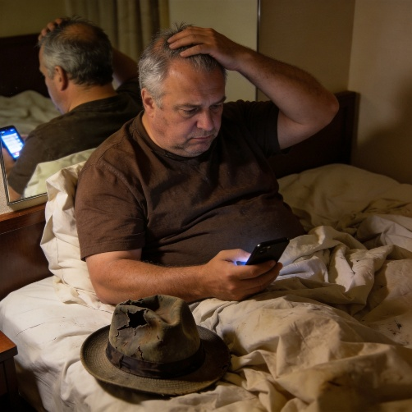
Because he was the last person to have seen Justin Tillman, on the run again for yet another financial crime, Harry had decided he was the one to find him. What’s more, he’d seen him in the company of Jimmy Klein, another crook involved in the perfumes and jewellery business, and Stelios Giannakopoulos, the owner of the biggest chain of upmarket jewellery shops in the world.
“But who will pay us, Harry?” Beryl had asked.
“Sam Morsey told me he’s on an FBI most wanted list for financial fraud, sweetie, and someone has put up a two-hundred-and-fifty-thousand-dollar reward to find him leading to his arrest.”
That was why he was in Cyprus, he reminded himself. This was the ultimate skip chase that would pay off his debts.

