EXTRACTS FROM AN OLD SPY STORY
AN OLD SPY STORY WAS MY FIRST BOOK.
AT 112,000 WORDS IT IS STILL MY LONGEST AND WAS BASED ON A LOT OF PERSONAL EXPERIENCE.
WHAT FOLLOWS ARE TWO EXTRACTS – THE PROLOGUE AND A CHAPTER ENTITLED REYNOLDS

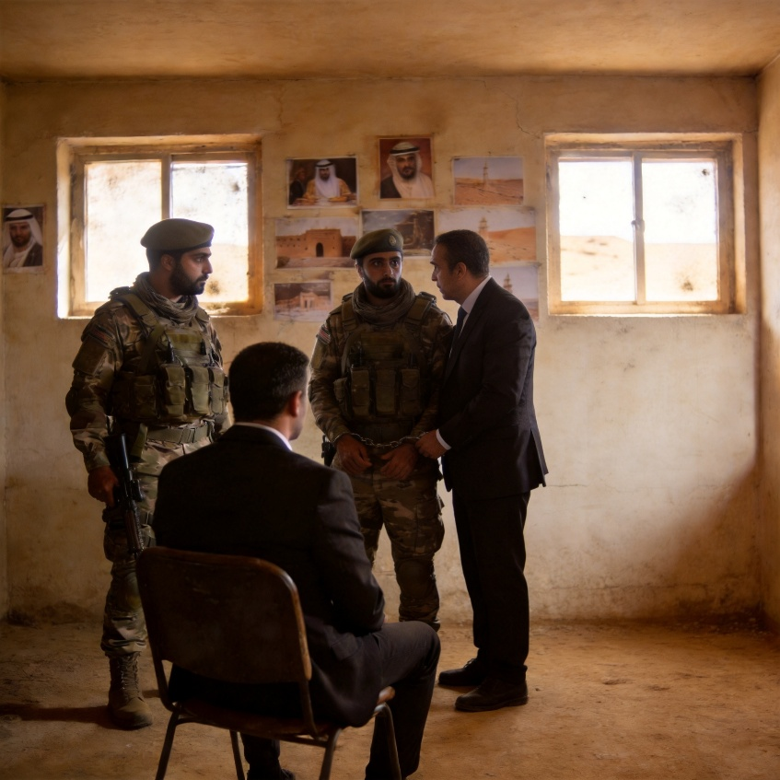

– THE PROLOGUE

Sixty years is a long time to look back and realise I should have been more cautious over my involvement with MI6, the government’s secret service. But I was younger then and was only concerned with finding ways to build my new business. I had no idea that offering to do one simple job would be like stepping into quicksand.
Neither did I know that MI6 was already racked with scandals, defections, and mistrust.
Books have been written about big name spies like Philby, Burgess, and Maclean from the so-called Cambridge Five who passed information to the Soviet Union during World War II until the early 1950s. I never had their privileged Cambridge University education or thought that the Marxism-Leninism of Soviet Communism was better than total devotion to king and country. Unlike Philby, Burgess, and Maclean, I did what I did because I was a patriot through and through. But, while their treachery has never been fully told, perhaps by writing this, I am exposing yet more inconvenient truths that were silently redacted.
Unlike Philby and co, I was a total unknown to those who drank tea and shuffled paper in the corridors of power. No one knew what Major Alex Donaldson was up to whilst drawing his salary and building his pension. No one knew that Donaldson spent much of his time in a dingy office on the second floor of a block in Regent Street and in a smoky pub called The Feathers in a side street of Victoria.
I never questioned it either because I had no idea how secret government departments worked. My upbringing had ingrained in me a bizarre sense of respect for those I imagined had greater knowledge and authority. I merely thought this was the way things worked and did as I was told.
What I slowly learned was that Donaldson was only very loosely connected to British Intelligence, and as you will see, it took me a long time to understand what was going on and far too long to do something about it.
I’ve always said it’s never too late to deal with outstanding matters, but things have never gone according to my plans. Until the last few days, that is.
My name’s Oliver Thomas. I’m eighty-six years old, but when I was pulled from the passport control line at Heathrow Airport and escorted to an office like, a common criminal age didn’t seem to matter.
I was not unduly concerned about being arrested until a dark silhouette stood over me with his back to the window. For reasons you will learn, I have a deep dislike of silhouettes. I was tired and had no wish to look as if I was about to cry, but my spectacles had fallen off and my eyes were sore. The glasses had disappeared beneath the table alongside my black bag and walking stick, so how could I have possibly seen the policeman’s face through a stream of tears?
I suppose that growing old means becoming clumsy. I needed the glasses for reading, but I could have ditched the walking stick. For a week, I’d managed perfectly well without it. Things still bent and did their job.
In fact, a few days ago, I even had to run and bend down all at the same time. It was the only way to retrieve the gun I’d dropped.

CHAPTER – “REYNOLDS”
Donaldson then gave the screw another turn.
I had been to Algeria again on business but then flew to Amman in Jordan because Donaldson had apparently set me up with an appointment with the Ministry of Defense.
In Amman, I would often visit the souk in the evening to look for a small gift for Sarah. When I returned to my hotel that night, a bearded Arab in smart white dress was sitting waiting for me and running a string of brown-coloured beads between his fingers, just as I was fingering my new-found present for Sarah in my pocket.
He stood. “Salaam Alekum,” he said with his hand outstretched. There was the briefest of pauses. “Mr. Thomas?”
Now this was surprising because my passport for immigration and visa purposes when I arrived in Amman had been a special one, prepared and given to me by Donaldson in London. It was all done in readiness for the meeting he’d arranged with the Jordanian Armed Forces the next day.
This new passport was in the name of David William Reynolds, and I had not shaved whilst in Algeria and Egypt to better match the photograph.
My Oliver Thomas passport lay secure behind the lining of my black case. At the time, I held three passports in the name of Thomas, although I normally only carried one. The others would have been at home or lodged with embassies, awaiting visas for future trips. On this occasion, the lining had been the hiding place for the Reynolds passport until just before my plane landed in Amman. Then, just before touching down, I had hidden the Thomas one, recovered the Reynolds one, and passed through immigration as David Reynolds.
Faced then with a visitor in the hotel lobby addressing me as Oliver Thomas, I was, at first, unsure how to respond. I decided on caution. “Alekum essalaam. And you are?” I asked.
“Derhally, sir. Fouad Derhally. Major Donaldson informed us you were staying here,” he said.
“Major Donaldson?”
“I think you know him, sir.”
I maintained my caution. “I do,” I said.
“Yes, sir. Mr. David Reynolds also confirmed you were staying here.”
This was odd because I was ostensibly David Reynolds.
“Mr. Reynolds?” I asked.
“Yes, sir. He is coming from England,” the man said in his Arabic way.
This was true, but it was still very odd.
“And where is Mr. Reynolds at present?” I asked the man.
“He is coming from the British Embassy, I believe, sir.”
“Is he? And how do you know Mr. Reynolds?”
“He arrived yesterday, sir. He flew to Amman from Algeria.”
Even now, years later, I remember exactly how the man spoke. But it was me, as Oliver Thomas, who had flown from Algeria just the day before. The confusion, combined with the heat of a late afternoon in the middle of July in Amman, brought on a sticky sweat. But what happened afterwards has been a recurring nightmare that produces regular sweats even in December in England.
I walked with the Arab to the corner of the hotel lobby, and we sat briefly by a potted palm and ordered coffee. We talked pleasantries until the coffee arrived in a pot and was served by a bearded man in white robes and a red sash into tiny cups on a brass tray. Little was said, and the coffee ritual only served to extend the time I spent with the man. But eventually, he said, “So, sir. There is an appointment for you as arranged. You will meet General Najib Jamal tomorrow at eight in the morning, sir.”
The man spoke to me over sips of the coffee but never looked directly at me. I know his eyes were black and that one manicured finger bore a fine gold ring with a blue stone. But there was no eye contact. Then, with an over vigorous shaking of hands, he left.
It was ten hours later that the man called again and escorted me to an official-looking black car parked outside. Sometime later, we arrived at the gate of what I took to be a military headquarters with guards and guns outside. We were ushered through, and then I was asked to get out. The black car drove off, leaving me standing in the heat of the hot morning sun. I was then immediately met by another man in an army uniform and was taken across a compound, past flat-roofed buildings and through a door into a dusty room with
I can recall everything about that room.
The general, or whoever he was because he had discarded the jacket part of his uniform that the badges and ribbons were not apparent, was seated at a desk with a gilt framed picture of a young King Hussein behind. He was flanked by three younger military men who wore khaki uniforms and offset berets. And there was a fourth man in a crumpled dark grey suit and tie, looking not unlike myself who looked distinctly English and also distinctly nervous.
The view of that room is imprinted on my mind.
Perhaps it has been embellished by time, but despite the briefest of minutes I spent there, it is still very clear. There were photos, inscriptions and passages from the Koran drawn in gold and red and conveying messages probably of peace and praise and loyalty to Allah. But the room itself did not convey a message of peace, goodwill, and loyalty.
“Mr. Thomas, please come with me.”
I can hear the order even now. There were no pleasantries, handshakes, or invitations to sit because the general was already standing. I was taken through to another room. The others followed, including the Englishman who appeared reluctant but said nothing. Then came the invitation to sit. An outstretched hand pointed. The seat was hard, with no arms, and I sat with my hot sticky hands clasped in my lap. The general, if that is what he was, talked whilst the others stood around him in their uniforms and shiny boots.
The Englishman, for that is what he proved to be, was standing beside one of the soldiers furthest from the main group. It was then that I saw the handcuffs and heard the words that I still remember to this day.
“This is Mr. Reynolds, Mr. Thomas. Mr. David Reynolds. Mr. Reynolds has made a few mistakes. He talked too much to the Israelis, Mr. Thomas. Far too much about what is not important. What is important is that from today, we would like you to become Mr. Reynolds. It will be very useful for everyone. You can also be Mr. Thomas. But for certain tasks related to the ongoing situation in the Middle East, of which you are well aware, it has been decided that it will make things, what shall we say, easier—no, convenient, no, efficient—yes, that is it, efficient. It will be more efficient and convenient if you are occasionally able to take over from Mr. Reynolds for the goodness of international relations, officially.
“What is more, Mr. Thomas, is our mutual friend Major Donaldson approves of this bold plan. That is also what we say, official. Ha.”
The general finished by laughing a little, as though embarrassed. I myself stood up, objected, and asked for a better explanation. But the general just raised his hand. No more explanation was forthcoming. But the menace came all too quickly.
“Your wife is Mrs. Sarah, isn’t it, Mr. Thomas? And your son is Robert, isn’t it Mr. Thomas? They must not know. Do you understand? No one must know. No one knows about this most important decision even now, except our mutual friend Major Donaldson. Major Donaldson knows. Major Donaldson knows everything, you see. Major Donaldson is a good friend to us. He has arranged everything. Even our young king does not know, Mr. Thomas. Some things are best dealt with in—how shall we say it?—in strictest confidence. It is best for everyone. Even your queen and your own prime minister—no one knows. No one then has to deny knowledge about your legitimate business activities, and you can run your other very useful assignments as Mr. Reynolds whenever it is appropriate. It is safer for you. That’s it—safer and better. It will be easier for you also. And it will be very useful for relations. You understand? You see how it is?”
I had not understood at all, but I had, suddenly, become David Reynolds and was about to become further enmeshed in a sticky web of intrigue that lasted years and where struggle meant even more entanglement. I had been caught like a fly in a spider’s web, although it felt more like barbed wire.
But things had then happened very suddenly.
The general nodded to the soldier who was fastened by handcuffs on his left hand to the silent Englishman. The man undid the bottom button of his khaki jacket with his free right hand, and a shiny black pistol was taken from a leather holster inside.
The real and mysterious Mr. Reynolds, who had, so far, said nothing, froze. He stared with wide eyes at me, his fellow Englishman and apparent replacement, and the blood visibly drained from his face. But still he said nothing. The gun was raised to the side of the head of the real Reynolds. The poor man closed his eyes and seemed to clench his teeth. Then there was a bright flash and a loud bang as the man’s head twisted violently over his neck. A red hole appeared above the ear, and the body slumped to the ground with one arm still upright, attached to the uniformed assassin. Blood gushed from the hole onto the floor.
I admit I was in too much of a state of shock to say or do much after that, and what happened in the minutes afterwards was unclear.
I remember Reynolds’s body being dragged away by the handcuff that held him to his killer and being pulled through a doorway to a darker room with what looked like a plain concrete floor. I saw the soldier who had shot him release the handcuff from his own wrist, and the body of Reynolds slumped to the floor. I remember the line of fresh blood that ran from just a few feet from me across the floor to the other room. I also remember the general taking me by the arm and me pushing him away. But what I said or shouted I cannot recall. I then remember both my arms being held by the other soldiers as I tried to fight myself free, but it was pointless because my legs and body felt weak from what I had just seen.
But, as I was marched back out into the sunshine, I remember the general talking nonstop in short incomplete sentences, as though it was just a routine morning’s work.
“Such a pity,” he repeated probably ten times, and there were other words that I think he spoke. “But that is the way of life.”
“We must all obey our orders.”
“At last, we now have a very fine replacement. This is good. It is best for everyone. We must carry on this good work.”
“This will be better now, you will see. Insh’allah. Things are clearer now.”
“Major Donaldson will be pleased with this. I shall report immediately.”
With that and with me still in a state of shock but not wanting to instigate a fight when I knew I was totally outnumbered, I was bundled into the same black car I had arrived in, and in a daze, I was dropped off at my hotel.
I felt completely numb. I went to my room, still in a state of shock, and there, I removed my glasses, washed my face, and stood before the mirror, looking at my new appearance. The fact was that, even to myself, I didn’t look like Ollie Thomas anymore. I suppose it was the light beard and my hair, which was plastered down with a parting on the wrong side. Then I went to lie on the bed, took out my Oliver Thomas passport, and laid it next to the Reynolds one.
I picked up the phone to call the British Embassy, thinking they might help, but then I stopped myself because I was already afraid of what I had got involved in.
Then, in my mind, I went over and over the words spoken to me earlier.
“This is Mr. Reynolds, Mr. Thomas. Mr. David Reynolds. Mr. Reynolds has made a few mistakes. He talked too much. It will be very useful for everyone if you are able to occasionally take over from Mr. Reynolds for the goodness of international relations . . . What is more, Mr. Thomas, our mutual friend Major Donaldson approves of this bold plan.”
And then the threats: “Your wife is Mrs. Sarah, isn’t it, Mr. Thomas? And your son, he is called Robert, isn’t it, Mr. Thomas? They must not know. Do you understand? No one must know.”
I remember thinking about Sarah back at home. Looking over at my white shirts hanging in the wardrobe and remembering that Sarah had carefully washed and ironed them before I left home, I remember that tears were coming to my eyes.
What the hell had I become involved with?
I thought about phoning home, but then thought better of it because of the threats.
“No one knows about this most important decision, except our friend Major Donaldson . . . Major Donaldson is a good friend to us . . . He has arranged everything . . . Even our young king does not know, Mr. Thomas . . . Some things are best dealt with in strictest confidence . . . Even your queen and your prime minister . . . No one knows . . . No one then has to deny knowledge . . . You can run your other assignments as Mr. Reynolds whenever it is appropriate . . . It is safer and better . . . It will be easier for you also . . . It will be very useful for relations. You see how it is?”
Oh yes, I was really starting to see how it was and what I was involved in.

