EXTRACTS FROM AN HONOURABLE FAKE
I wrote the first version of An Honourable Fake back in 2017 in the hope that Africa might soon see the emergence of a political hero who could reverse its long history of poverty and corruption and face up to increasing Islamic terrorism spreading from the north. In 2026 it seems we are still waiting.
It’s a longish book (105,000 words)
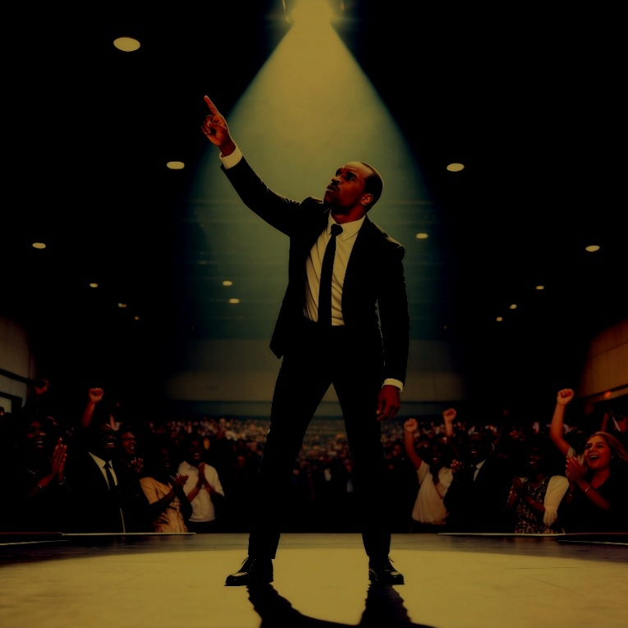

Excerpt from Chapter 2
Gabriel in California talking to the State Governor.
Gabriel didn’t like the way he was speaking right now. It was unnatural, but it was deliberate. It was like acting. Preaching was an act as well. He would often change his tone, his accent, and his style to reflect who he was speaking to and why. Right now, he was talking to a high-flying, rich American politician who he knew would not bother listening to soft words, sensitive phrases, and politeness. This man wanted to be impressed. It was a time for rough talk some American slang and a tone that suggested impatience, overconfidence, and brashness. Delivered like that, this man would be far more likely to buy into it. Preaching about prosperity gospel was, after all, pure salesmanship.
“The preaching business has changed since the Lord Jesus walked among us,” Gabriel went on. “He may not be happy with what some of the customers of his competitor Mohamed get up to, but I don’t blame Mohamed for that. It’s his preachers and the millions of disaffected youths who follow them who have a lot to answer for. It must hurt him lots. Mohamed was an OK guy. It’s his new brand of messengers that hurt him.
He paused to let the governor speak but he said nothing.
“So, you’re getting to know what the message is now, right, sir? It’s that material and financial betterment now meets with God’s full approval. Even he couldn’t hold back the tide, you see—it’s human nature. It’s not like it once was. For many black Americans and their African cousins, materialism fits neatly into their lives. The spiritual world still manifests itself in their everyday lives, but nowadays, it’s all about creating wealth. But that’s damn hard if your livelihood and personal safety is at risk, if all your hard work is exploited by the rich and the powerful and you’ve got no confidence in the future.
“So, you and your friends in Congress need to get with it, man. The old Christianity brought to Africa in the nineteenth century was Western. As someone once said, the old view was concerned with dualism - the dualism between the mind and the spirit, between this world and the next, between God and the devil, between the simple matter of day-to-day living and surviving and the soul.
“Africa’s where the missionaries went, but they didn’t finish their job, and it’s too late now because the world moved on. It ain’t as simple as it was. America is stuck. Europe is stuck. They’re so stuck they can’t change any more. They can’t even deal with their own problems because they’ve bound themselves up in red tape, social support they can’t afford and all that human rights shit.
“But did you hear the cheering last night, Governor? Did you listen deep? I never hide my message. If it makes for uncomfortable listening, then so be it. But if you want to stop this rot, this plague of terrorism, this economic sickness, and this epidemic of uncontrolled population growth and unemployment, you gotta understand that in African minds, that old simple dualism I mentioned is gone. It’s gone forever, my friend. It ain’t there anymore.
“They now worship wealth and money like it’s the Lord himself. It’s why they like my Italian suit, my silk tie, and my silky way with words. The suits are my uniform. It’s what’s necessary in modern show business, but they can’t get anything for themselves without freedom, and they won’t get freedom until they get leadership. They need a different sort of leadership, one that accepts the reality that the world faces genuine threats to its survival without some serious action.
“So, you understand my direction, Governor? Spiritual leadership works, Governor. It’s seriously lacking in the world right now, but it stirs folk into greater optimism. It makes them get up on a morning and go to work because they see a reason. They even work harder. Christian leadership, maybe even Christianity itself, is not cool enough anymore. You gotta make it cool. You gotta match them others—them others who think their way is so fucking cool that they even believe the earth is flat, that the sun rotates around the earth, and that God provides virgins for fulfilment after death. Their only objective is to sow seeds of discord, but it’s become so cool they leave home, go pick up a gun, and fix a grenade to their underwear. Sowing seeds of discord is now more cool than sowing seeds of liberalism and freedom.
“While you argue about the economy, jobs, health care, education and your own local problem over lack of water and while your government reluctantly sends a few US Marines to help stick pins in what remains of Bin Laden’s legacy, you know what’s going on under your nose?
“Where I come from five years have gone by since they said they’d halted the expansion of terrorist groups like Boko Haram. ‘They are defeated’ was the call. Two years later, it was ‘We are driving them back.’ Last year, it was ‘There are only a few pockets left.’ Whoever said all that, sir, was only after one thing—re-election to cloud cuckoo land. Because while they were dreaming up fresh words to pacify the masses, fresh wildfires of terrorism and social unrest were breaking out everywhere—the Middle East, Africa, the Far East. It was a mess then, and it’s a worse mess now. All the West does is hand out aid to make them feel better or pretend that bombing targets work when it really knows that only boots on the ground are effective. And meanwhile, economies stagnate, and the poor get poorer.
“Globalisation is what we’ve got here, Governor. Globalisation of the economy has led to globalisation of terrorism because globalisation fails the poor. And you know what the poor do when they got nothing better to do, Governor? They fuck, they breed, they reproduce. And what happens when you fuck and breed and you run out of food and water and you no longer have the means to support yourself? You migrate, or you join those that offer jobs with guns. Or you do both—migrate and take up guns.
“You and your friends up there in Congress need to start to understand why we’re where we are, and you can then move to the second question of how to deal with it.
“And why am I here again—my sincere thanks for the bed, breakfast, and other services, by the way, Governor. Why? Because my plans for dealing with the how are nearing completion. On my own, Governor. Got it? If I can get this far alone, think what the US, the EU, or the UN could do if it really put its mind to it. I know you already heard some, but it’s getting scary now, sir, ’cause I’m now ready. But Gabriel don’t scare too easy.
“So, Governor, you want part of my scary plan or not? Are you now convinced enough to take the president aside, whisper in his ear, and tell him that Africans have no wish to go back five hundred years, but that they, too, want to head toward that bright light of the future he keeps talking about.
“Tell him that the world’s economic system is failing, sir. Tell him that social unrest, fundamentalism, terrorism, or corruption is like a parasite, sir. It’s like a tapeworm that grows longer and longer inside and sucks the blood of the wealth created by the innocent poor. Tell him that the only way to kill this parasite is to change the system that widens the gap between the rich and the poor, between the haves and the have-nots and provide the protection for people to build their own lives in their own way. That’s real freedom, sir, and I once thought the US understood that word.

Excerpt from Chapter 14
Gabriel losing patience with the US Government, but his own plans are moving forward.

Gabriel was watching from an upstairs window of the Holiday Inn Express when the big, black car pulled up outside. A burly white security man got out, opened the rear door and, even though it was night-time, put on a pair of dark glasses. Daniel Bakare climbed out holding a phone to his ear. Simultaneously, Gabriel’s phone rang.
"Sorry I'm late. I'm downstairs."
"Yeh, so I see." Gabriel said. "Leave the big boy downstairs. We don't bite and we're unarmed and if the moon’s too bright for him tonight tell him to go see an eye specialist." He went to the door, opened it and waited until Bakare arrived outside. “Come in,” he said. “Take the weight off your feet. The bed's very comfortable."
Solomon, understanding Gabriel's mood offered Bakare the chair instead and went to stand by the window. Gabriel lay on the bed, hands behind his head, shoes and socks scattered on the floor.
"Shit, Gabriel, what's got with you? You ain't normally like this."
"No? Maybe I feel I'm being fucked about, Daniel."
"And who the hell's fucking you about?"
"Everyone. You included. How long we been talking now? Years. We've tried your recommended route - lobbying through people like your friend Governor Frank Jameson and a hundred others. Meanwhile, we just get on with things. On our own." He pointed a finger directly at Bakare's face. "When's everyone going to realise that Gabriel Joshua ain't no fool and what's more he'll deliver - if necessary, without any help from the US Government. Why do I waste time talking to you?"
"Things take time, Gabriel."
"Sure. Meantime more people fall into poverty, more people get killed, murdered, beheaded, raped, abducted. There aren’t too many Americans amongst them I've noticed but a lot of Africans. Who told you South Africa was a time bomb?"
"You did, Gabriel. You were right."
"So? What's your plan? Made any decisions?"
There was a silence of a few seconds although, looking on, Solomon decided it was only an awkward silence for Bakare. Gabriel just edged further back on the bed. head on the pillow, bare ankles and toes twitching impatiently. "Come on, Daniel. Spill. The plans? The decisions? What are they?"
"You jumped the gun, Gabriel."
"Who? Me?" Gabriel said in mocked shock and pointing a finger at himself.
"We've seen it. Very strategic, right on the border."
"Was it a good satellite picture, Daniel? Did you like the British flag? I'd stick some stars and stripes on the roof if you'd help."
"The Brits knew nothing till we told them."
"Why should they know? They're as long-winded as you. You talk to Taj Harding recently?"
(Taj Harding was a Parliamentary Under-Secretary in the UK Ministry of Defence. He had no real power and had to tread carefully but, being Nigerian by birth, had been a useful source of inside information on British policy in Africa. Daniel Bakare also knew him).
"Last I heard Taj was talking to the UK Defence Secretary."
“He did that two years ago, Daniel. And you talked to yours two years ago. You said you liked my ideas - but. I asked why the 'but'? You said it didn't fit US strategy. So, I asked what exactly was US strategy?' You seemed vague. Have things changed?"
"We're moving closer, Gabriel."
Another silence. Solomon turned away, staring out into the darkness. Bakare stood and walked a few paces. "So, who gave you permission to set up something in that nice, strategically placed corner on the border with Niger? You want to tell me?"
"No. Why should I? It's private property and even if I did would it make any difference to US strategy to deal with the spread of the COK’s terrorist mob and all their other hangers-on…... etcetera, etcetera?"
"It might."
"So, if I told you we got permission from the President would you believe me?"
"Which President? Hama Dosso from Niamey or your own President Azazi from Abuja?"
Gabriel shrugged. “Does it matter? We own the land and can do what the hell we like with it, without Uncle Sam interfering."

