EXTRACT FROM A PROFESSIONAL VENDETTA – where Professor Eddie Higgins first meets Isobel Johnson, the chief executive of Vital Cosmetics.

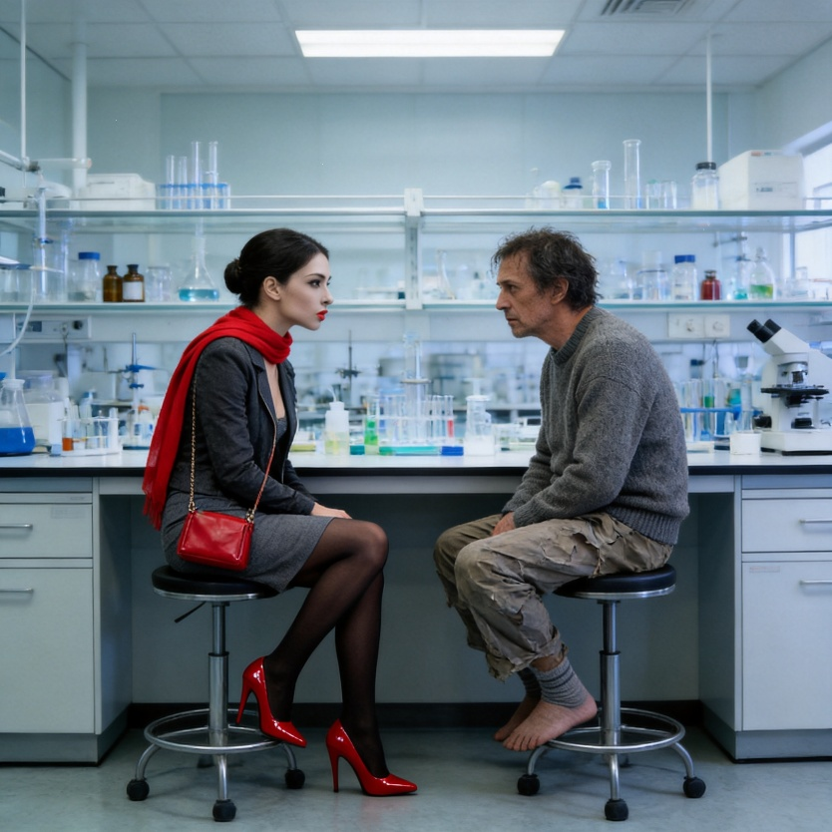

Standing there was an unexpectedly tall, slim, black-haired woman in a dark suit who looked much younger than he’d imagined. This wasn’t the squat, savage-looking, bespectacled and mousy-haired chairman and chief executive of his imagination but a taller, more delicate creature with pure white skin, shiny red lips and deep brown eyes surrounded by thick, black paint. She smiled at him.
“Professor Higgins?”
“Call me Eddie.”
“May I come in?”
Isobel Johnson slipped passed him and so he checked her from behind. She was wearing shiny, red, high-heeled shoes and black stockings. A flimsy red scarf was draped over a dark grey jacket and beneath that a matching grey skirt. A red handbag hung from her shoulder.
Eddie’s low interest in personal details meant he hadn’t learned much about her beforehand. Had he bothered he’d have discovered that Isobel Johnson was highly regarded in some circles. She was a regular contributor to magazines on fashion and such-like and was often called upon to speak on the radio or TV or at conferences in support of women in business All Eddie knew was that not a drop of rain had touched her so she’d clearly arrived by car or taxi, certainly not by bicycle.
He was still holding the door open in his damp socks and with his glasses hanging on the cord around his neck “We banned those sorts of shoes some years ago,” he said. “They leave marks on the laboratory floor.”
Isobel turned and looked at him and Eddie saw a striking resemblance to a waxworks model of a Chinese concubine he’d once seen.at Madame Tussaud’s. It was the glossy red lipstick that clinched it.
“Of course,” Isobel said. “How thoughtless of me. Shall I leave them outside?”
Eddie watched how she bent over in the tight skirt, removed the shoes and place them neatly against the wall. She then brushed the skirt down and turned to look up at him from a slightly lower altitude. “Better?” she asked.
“Thank you,” Eddie said. “Please come in. Take the stool by the incubator. Tea?”
“Thank you.” She paused. “This looks very complicated Professor Higgins.”
In looking to see what it was that was so complicated, tea spilt on the floor so Eddie wiped it with his foot. Hot wetness seeped into his still damp, grey socks but he needed to concentrate. “Gas chromatography and mass spectrography. Some students’ work. Results from tests on Krabok nut oil,” he said.
“And what does it tell you?”
He slid the mug of tea towards her leaving a trail of wetness and put two Rich Teas alongside it. That’s when he noticed her fingers, the shiny red nails and three rings – gold with clear little stones. “My students were looking for therapeutic properties, particularly antifungal ones amongst the aldehydes and esters components in nut oils.” He was speaking somewhat distractedly because nail paint always intrigued him. Why did they do it? What was the purpose?
“I see,” Isobel replied.
“In your cosmetics business, you call them essential oils, Miss Johnson.”
“Isobel, please.”
“In theory, when choosing an essential oil for human use you would want one with a high therapeutic value and low toxicity. There are many different compounds within each of the major categories – in fact there are several hundred individual chemical substances in these oils. That makes it difficult to evaluate them chemically. Even though a chromatograph may show only a few of the constituents of an oil, one still needs knowledge of many individual substances and their properties to read and understand a GC-MS report. Some components can be quite toxic in large quantities.” Eddie glanced at her from the corner of his eye. “But you know all that of course. You’re in the cosmetics business.”
Over his half-moons he watched her looking at the screen through two strands of straight black hair that had fallen forward. Her brown eyes peered through long black eyelashes that were either false or fluffed up with those little black brushes he knew they use to improve the flutter effect. Her eyebrows were thick, black and neat mirror images of each another.
“This,” he said pressing a few keys, “is a comparison of two oils that you might think were identical – lavender oils. Lavender is useful for teaching students. If lavender is grown above 2,000 feet, the ester content increases. This, some say, makes high altitude lavender oil more useful in aromatherapy and therefore more profitable.
“We’re talking serious biochemistry coupled with complex benefits and toxicity testing, Baroness. Claims, for instance, that lavenders have calming effects and antispasmodic properties are - what shall I say? - mostly hearsay. Most users and sellers of aromatherapy products don’t have the slightest understanding of the chemistry behind the ludicrous claims they make.”
Eddie, getting into the swing of things now, pulled up another stool and sat down close enough to find her perfume quite overpowering. “And neither do perfume and cosmetics manufacturers,” he added, wrinkling his nose.
She smiled. “But whoever heard of someone dying from an overdose of skin cream, Professor?”
“And whoever heard of someone taking an anti-ageing cream who finds the ageing process has been stopped in its tracks,” he snapped back.
“But it’s their choice.” She said, “If they feel and look better then…”
Eddie erupted. “The word anti means against,” he said. “Anti-ageing therefore means against ageing. It means something, in this case a mix of chemicals, that acts against ageing or at least delays the biological process of ageing. No such single chemical exists. Anti-ageing does not mean lessening the visual signs of ageing. The cosmetics industry uses expressions to distort scientific fact. It turns clearly understood words and changes their meanings. It distorts truth to get around advertising standards that are, in themselves, inadequate. The cosmetics industry lies, misrepresents and steals words to sell products that don’t work.”
“Really, Professor, I don’t quite……” but there was no interrupting Eddie when he was on a roll.
“Take the word serum,” he said. “Ask any woman these days what serum is and she’ll tell you it’s cosmetic. No. it’s not. Serum is a highly complex body fluid in which blood cells circulate in blood vessels. Serology is a scientific subject in its own right. Serum is not, and never can be, a mix of a few synthetic chemicals in a drop of oil sold in pink tubes and little bottles. They stole the word, Baroness. “
Isobel looked appalled as if no-one had ever spoken to her like this but Eddie still hadn’t finished.
“And you think that someone in a society like ours where good quality food of all types is cheap and available in indecent abundance needs to take food supplements and consume energy drinks as if they’re vital for general health and performance?”
He was pleased how he’d slipped in that indirect reference to the new range of Vital Sports drinks. He made a noise that was meant to sound triumphant
“What on earth is meant by replacing lost electrolytes for example?” he went on. “Do they really mean the sodium chloride in sweat? If so, say so. Does anyone who drinks these concoctions properly understand words like hypotonic, hypertonic or isotonic? And, even if it was possible, would anyone really need to improve and speed up their metabolism?”
Baroness Johnson wriggled off her stool. “Professor Higgins. I thought I was here to listen to your views following a talk you gave to our staff a short while ago.”
That was true. Talking to staff now and again was one of the jobs of the scientific adviser. So far, Eddie had only talked to them once, formally, but once was enough. He’d walked around their manufacturing area more than once but had found senior staff boring, disinterested, arrogant, flippant and, quite frankly, rude.
Eddie was still seated and Isobel was now facing him at eye level so he stood because his mother had always told him to stand if a seated lady, he was conversing with, stood.
“Yes,” he said, “Because you had concerns about the way your business was being run. You’re in the cosmetics and health products business and you’ve appointed a scientific adviser. Well, here I am – asking questions and advising.”
Isobel sniffed. “Professional advice is one thing. Personal views are quite another, Professor.”
“Not so,” Eddie said crossly. “For a scientist, different sets of views must be allowed to overlap until indisputable facts tilt opinion one way or another. And, anyway, the message I received was that you wanted opinions on staff motivation and commitment, not just their scientific knowledge. That is a pity because as none of your staff are properly qualified their ability to question technical data is very limited. But it was as if you were suspicious of goings on within the company. Am I right?”
She sniffed again so he knew he was right. He continued: “If so, then as your scientific adviser and as I am not at all clear who I actually report to, I would like to say that Vital started giving me cause for concern several months ago.”
“I see.”
Eddie swallowed cold tea and wiped his mouth. “So, do you want to hear my views?”
“Yes,” she said. “That’s why I’m here. And if you are in any doubt, Professor, you report to me.”

